1. **Perform basic video processing operations on the captured video• Read captured video in python and display the video, in slow motion and in fast motion.**

**Aim:**

The aim of the experiment is to read captured video python and display the video, in slow motion and in fast motion.

**Code:**

import cv2

import numpy as np

video_path = r"C:\Users\prith\Documents\CV\cvVideo.mp4"

cap = cv2.VideoCapture(video_path)

if not cap.isOpened():

print("Error opening video file")

else:

while cap.isOpened():

ret, frame = cap.read()

if ret:

cv2.imshow('Frame', frame)

if cv2.waitKey(250) & 0xFF == ord('q'):

break

else:

break

cap.release()

cv2.destroyAllWindows()

**Input:**

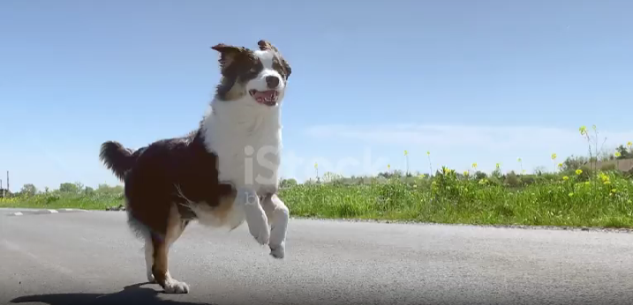

**Output:**

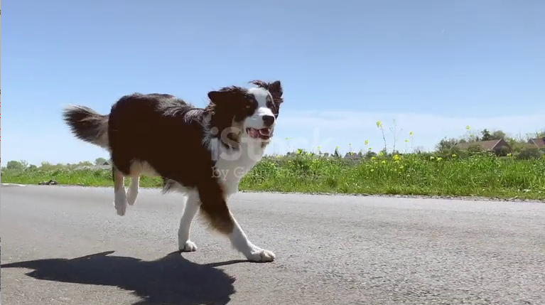

**Result:**

The captured video is read and displayed in slow motion.